Spain’s Musical Culture
The most popular instruments in Spain are the Spanish guitar,the bagpipes, the castanets…
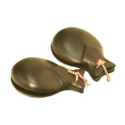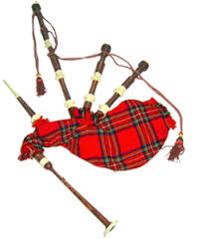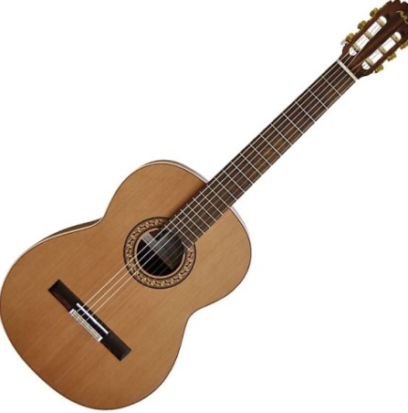
The popular songs are reggaeton and flamenco in Spain
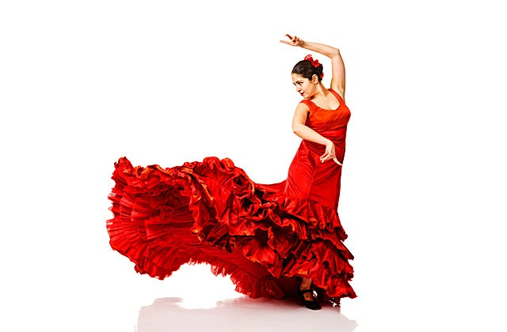
The most popular music in Spain is trap, but before it the reggaeton is the most popular. Flamenco is from Spain for a lifetime. The Flamenco artists are Camela, Los Chunguitos, Paco de Lucia…
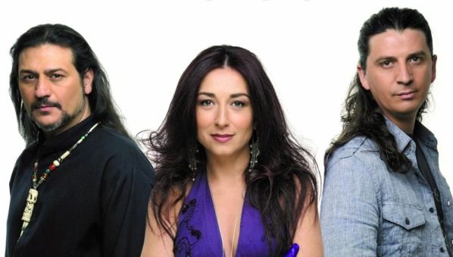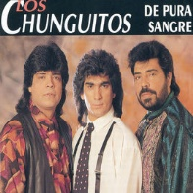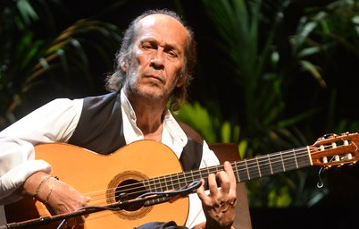

There are two songs that have won the Eurovision contest, the first was La, la, la (1968) and the second was Vivo cantando (1969). Also, there is a TV show called Operación Triunfo. Some important artists from Operación Triunfo are David Bisbal, Rosa López and Aitana War.
. 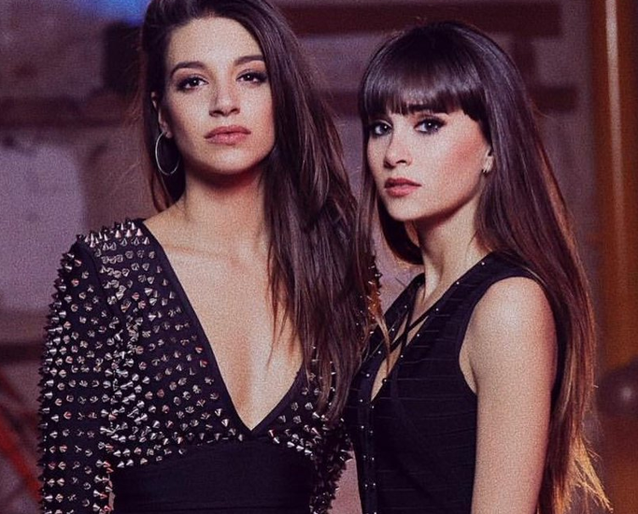 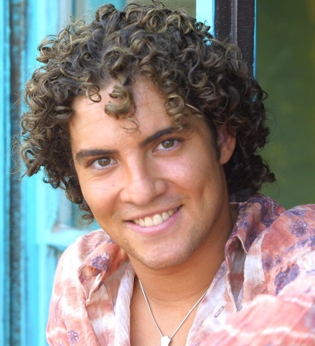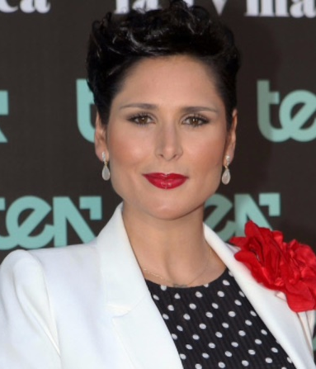

Some of the most popular rooms in Spain are Riviera, WiZnik center, Jambore, Palau Dalmases…

Rubio is the most popular singer in spain... (i search him but he is a basketball player?)

In Spain there are some award-winning songs such as canciones premias.

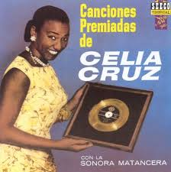

Pablo Alborán is a Spanish artist who is followed by all kinds of ages.

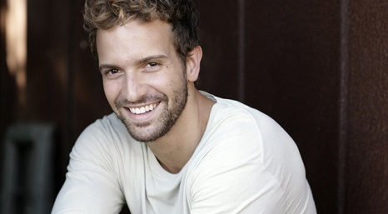

The traditional instruments in Spain are the flamenco guitar, the cajón flamenco and the tambourine…

The famous musicians are David Bisbal, Rosalia, Pablo Alborán…

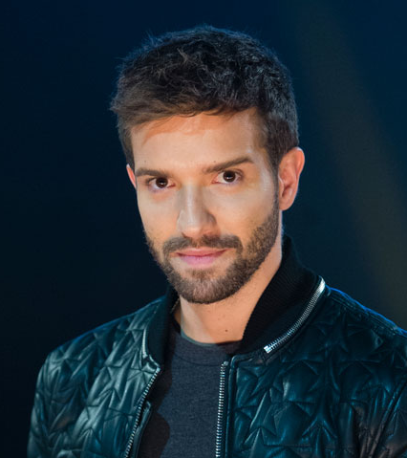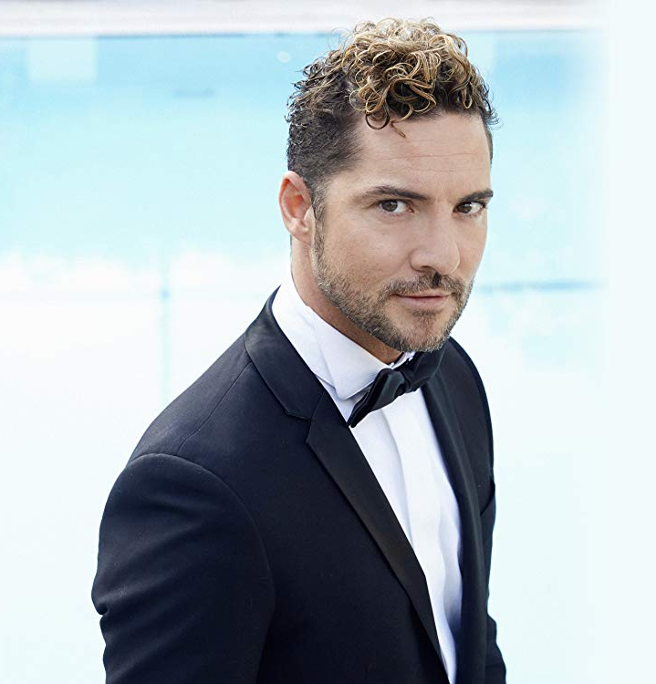

Some traditional dances in Spain (specially in Andalusia) are the Jotas Serranas, sevillanas and flamenco. There are special clothes for this dances.

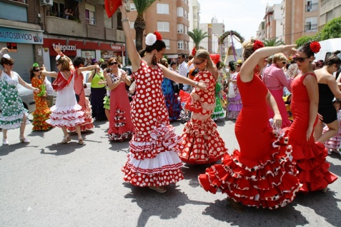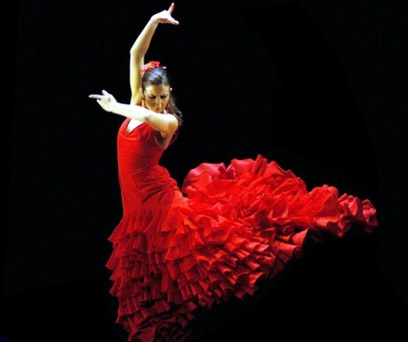

Spain’s best performance in Eurovision was by Massiel in the sixties with the song La, la,la.
