ID OF FRANCE
There are 440 city in France. 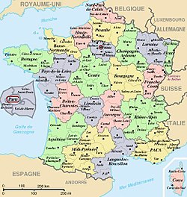
There are 67 million person in France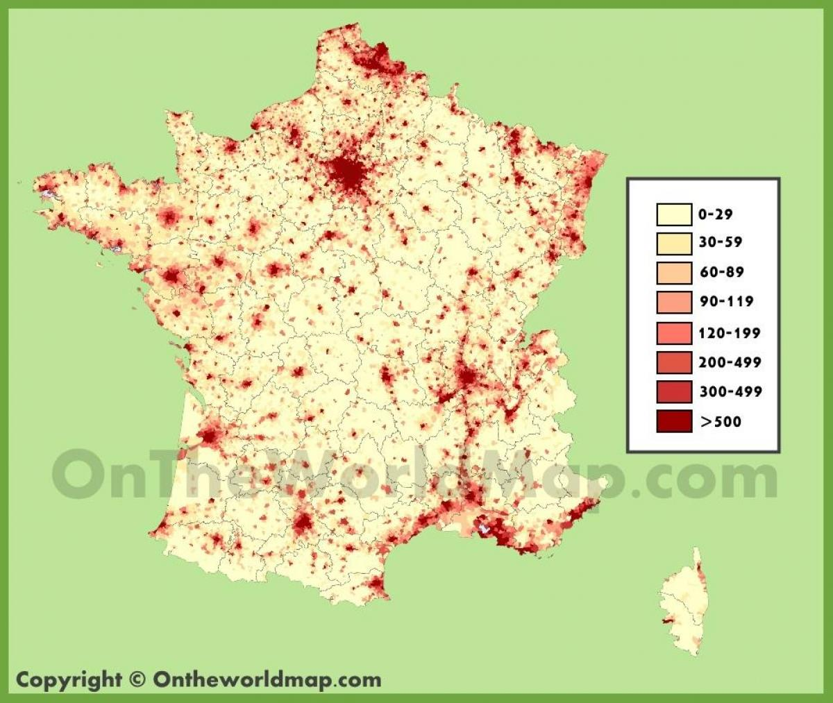
France’s president is Emmanuel Macron
France’s capital is Paris
Language of France only French
Currency of France is euro, before the euro it was the Franc.
Founder of France is Clovis in the 5th century
There are 13 regions now. Before the used to be 22.