Who are the most popular celebrities?

Johanna Tukianien is taking place in TV shows.She is 40 years old.

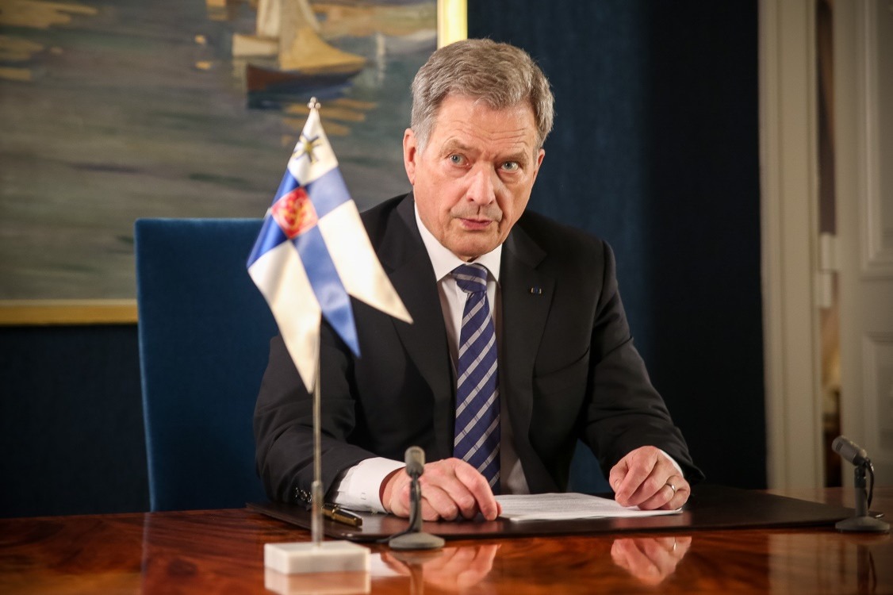

Sauli Niinisto is president of Finland.He started him job on 1 Of March 2012.
Who is most popular sceintist?
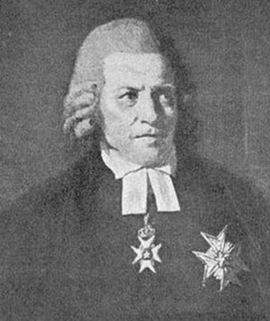
Jacob Gadolin was born on November 24, 1719.In 1745 he became professor of philosophy and maths.He served as professor of physics in 1753 and he served as professor of theology.Then he became succesful bishop in 1788 at the Swedish Church.And then he died on 26 September 1802.
Who are most important historical figures?
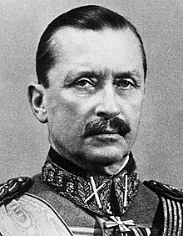
Carl Gustaf Emil Mannerheim is soldier and politician of Finland.He was president of Finland between 1944-1946.He sucsessfully led the defend of Finland opposite Soviets while II.World War.
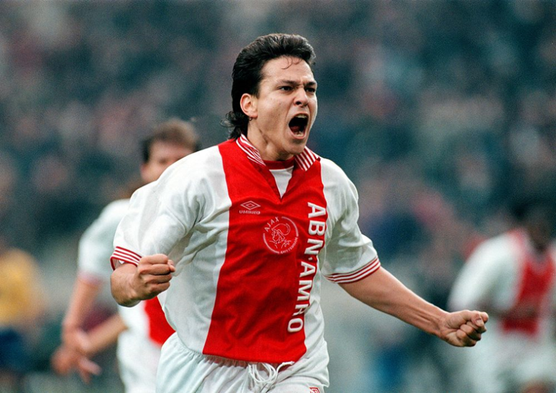
Who are the famous football players?

Jari Litmanen is Finnish football player.In 2003, he selected by Finnish Football Federation as best player of the last 50 years.
Who are the most famous couple?

Minttu Ja Kimi Räikkönen

Who has Nobel prize?
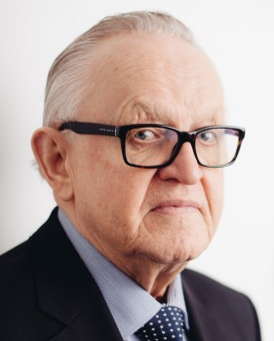
Martti Ahtisaari is Finnish politician.He was recently awarded the 2008 Nobel Peace Prize for him mediation, in Kosovo, Europe, Africa, the Middle East and Far East Asia.

Who is the most famous actor?
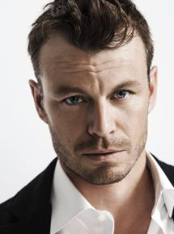
Peter Franzen is Finnish actor,author,screenwriter and director.

Are there any succesful youtubers?
She’s Papananaaama

